TEMPLATE CREATION

BOOK DETAILS

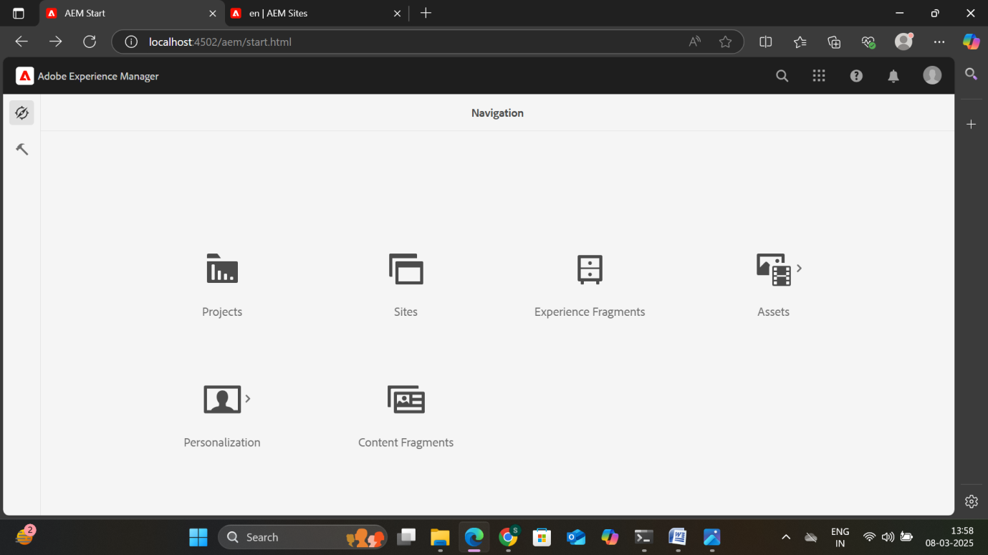

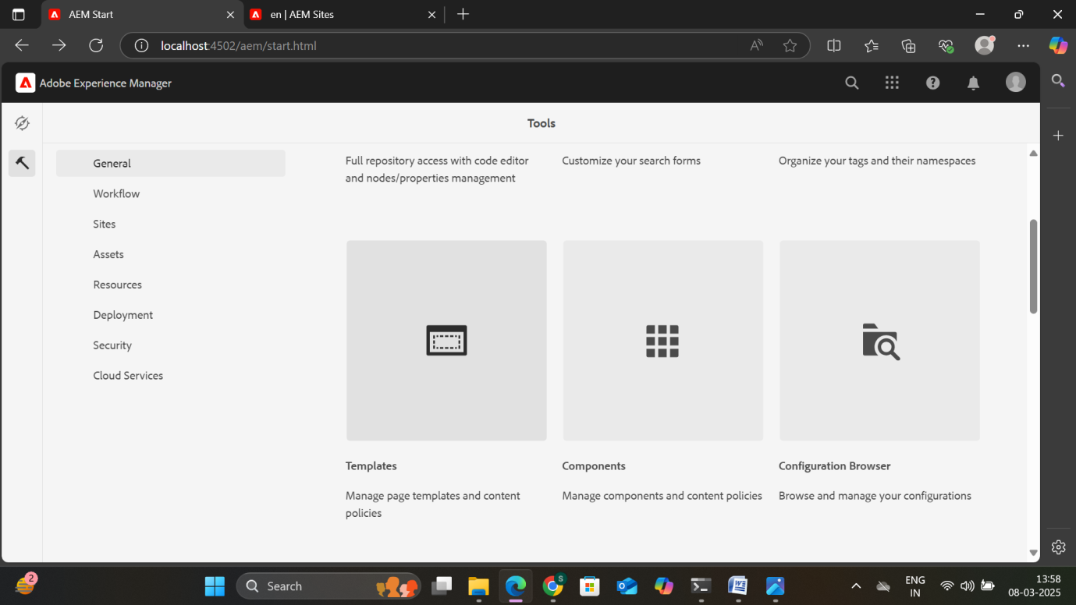

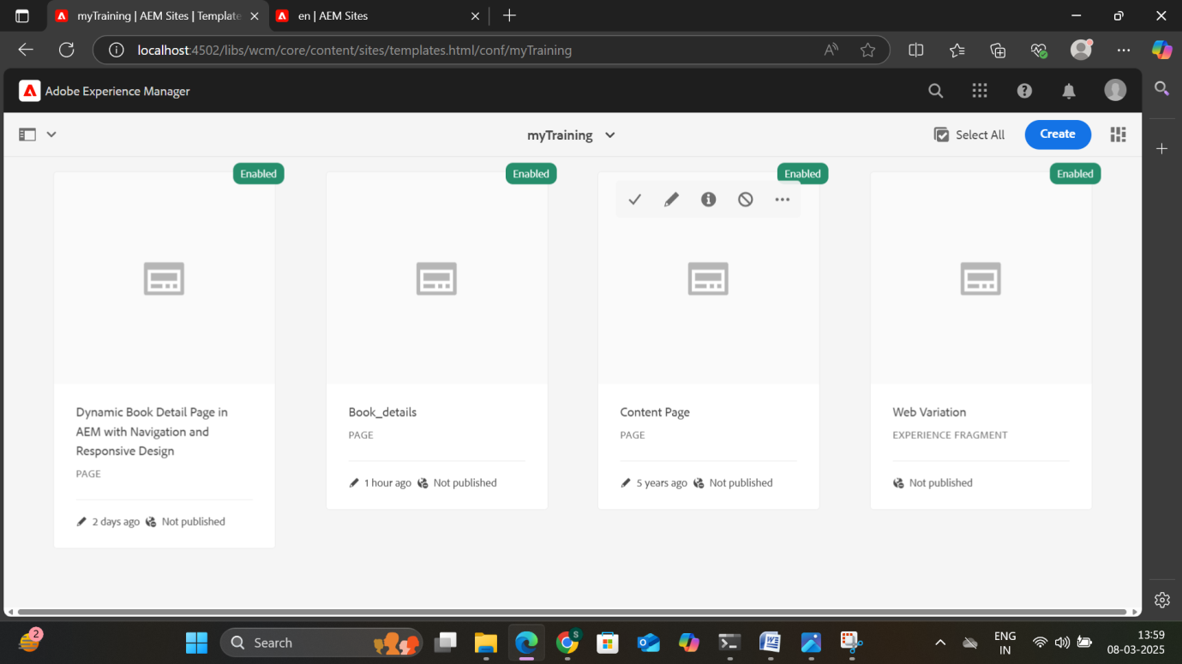

STEP 2: Creating 3 pages under the Content page and 10 pages under the Books page.

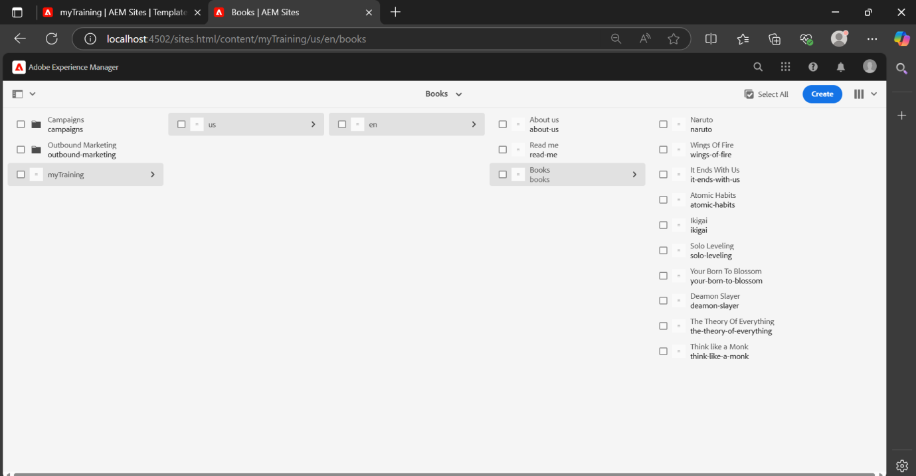

STEP 3: Adding Header and Footer

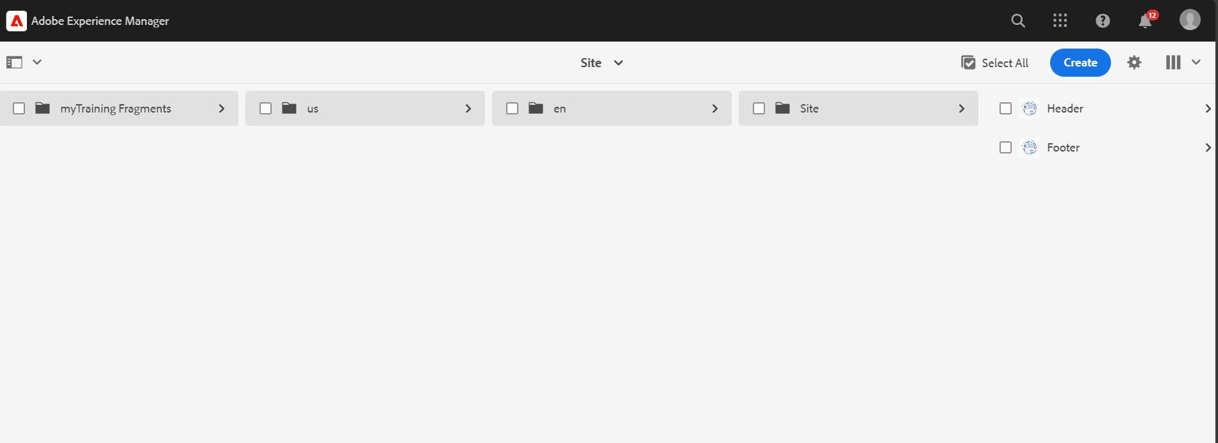

* Need to choose the master fragments.

OUTPUT:

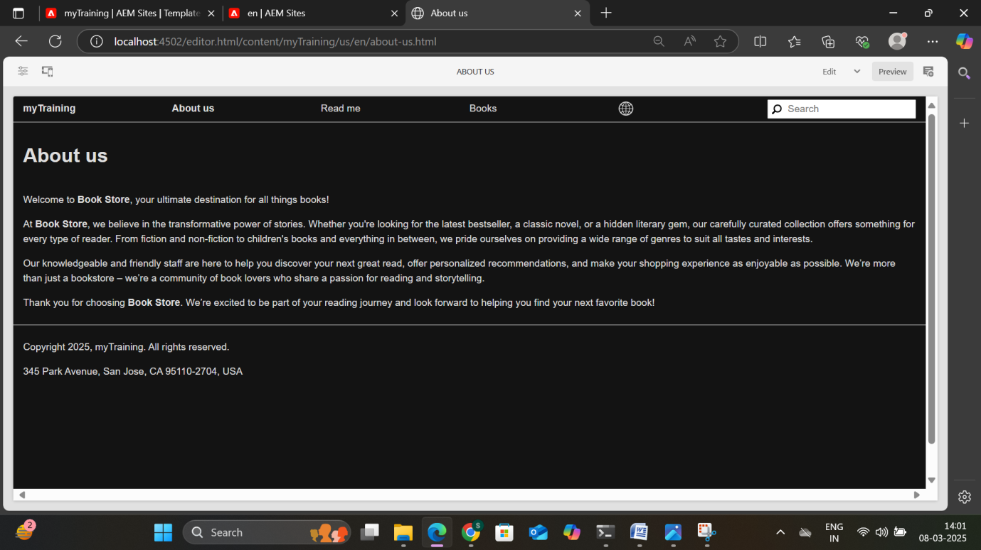

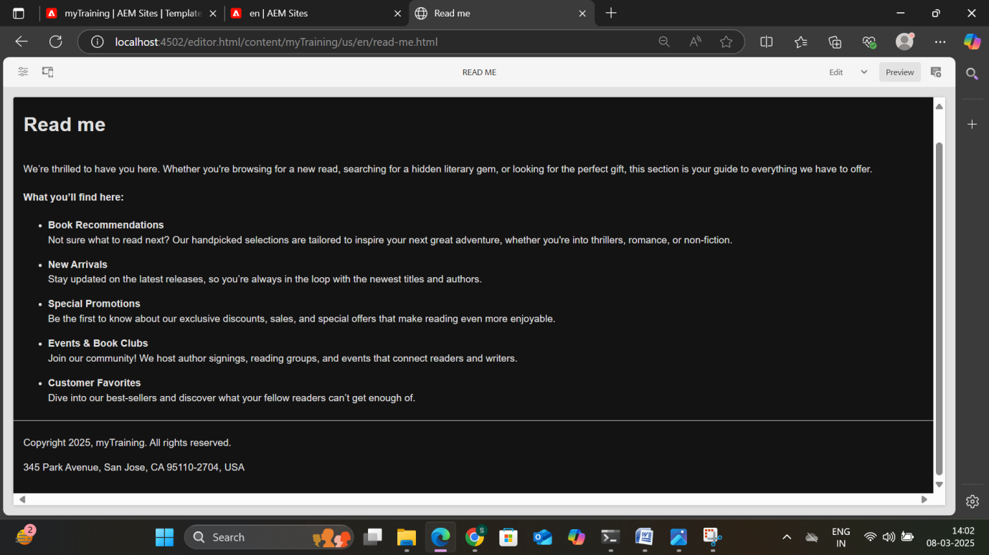

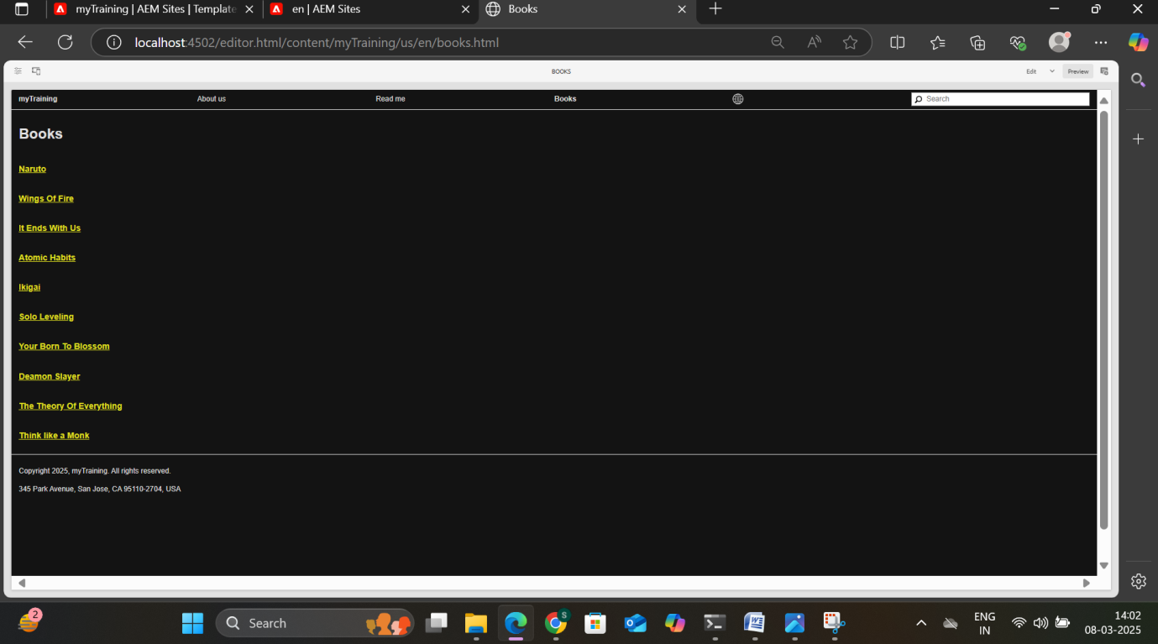

NARUTO:

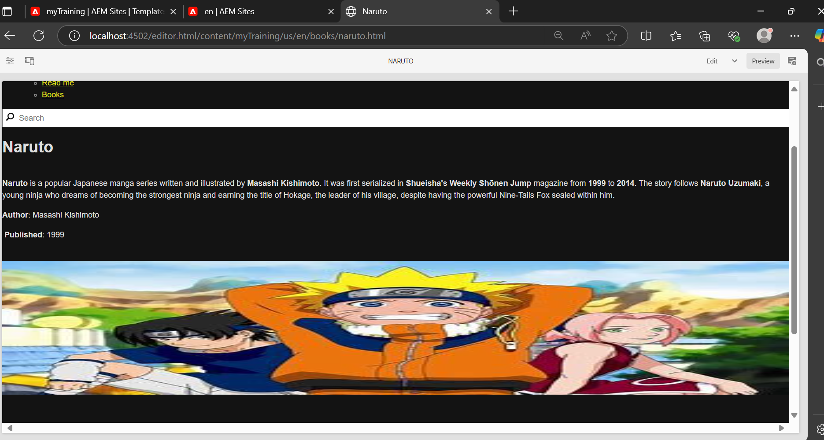

WINGS OF FIRE

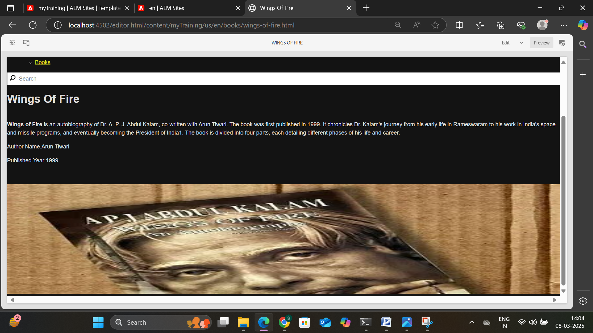

IT ENDS WITH US

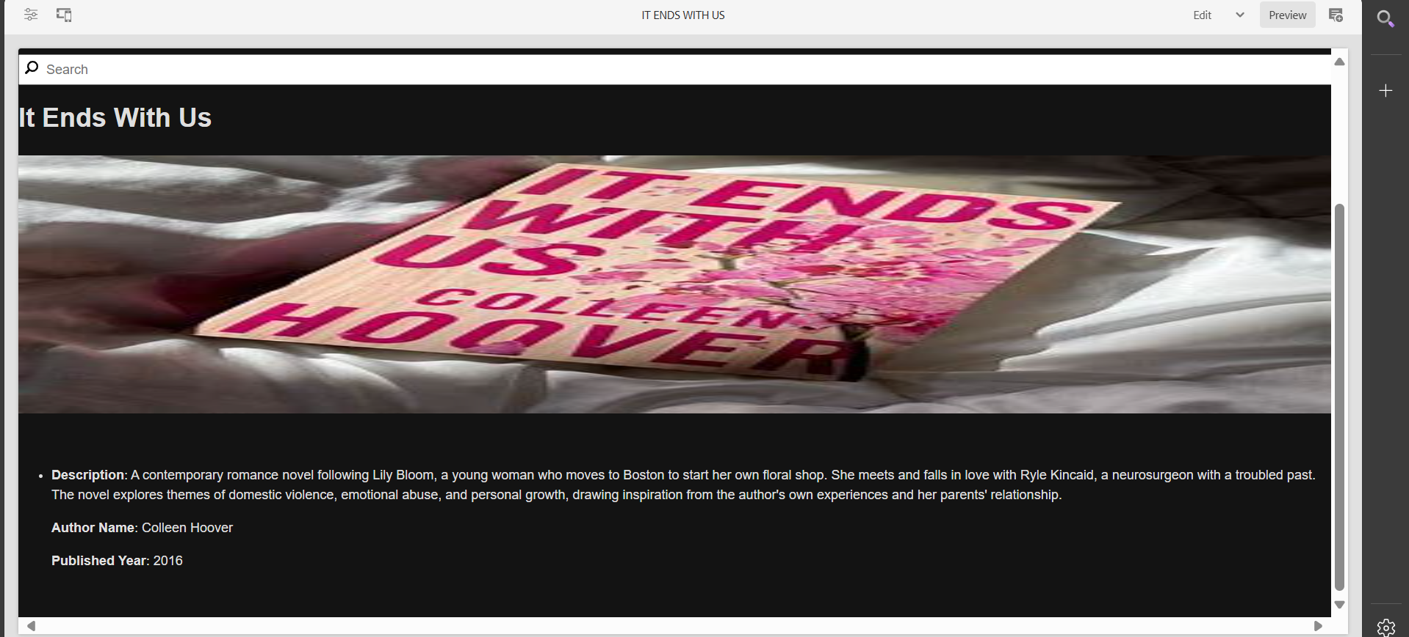

ATOMIC HABITS

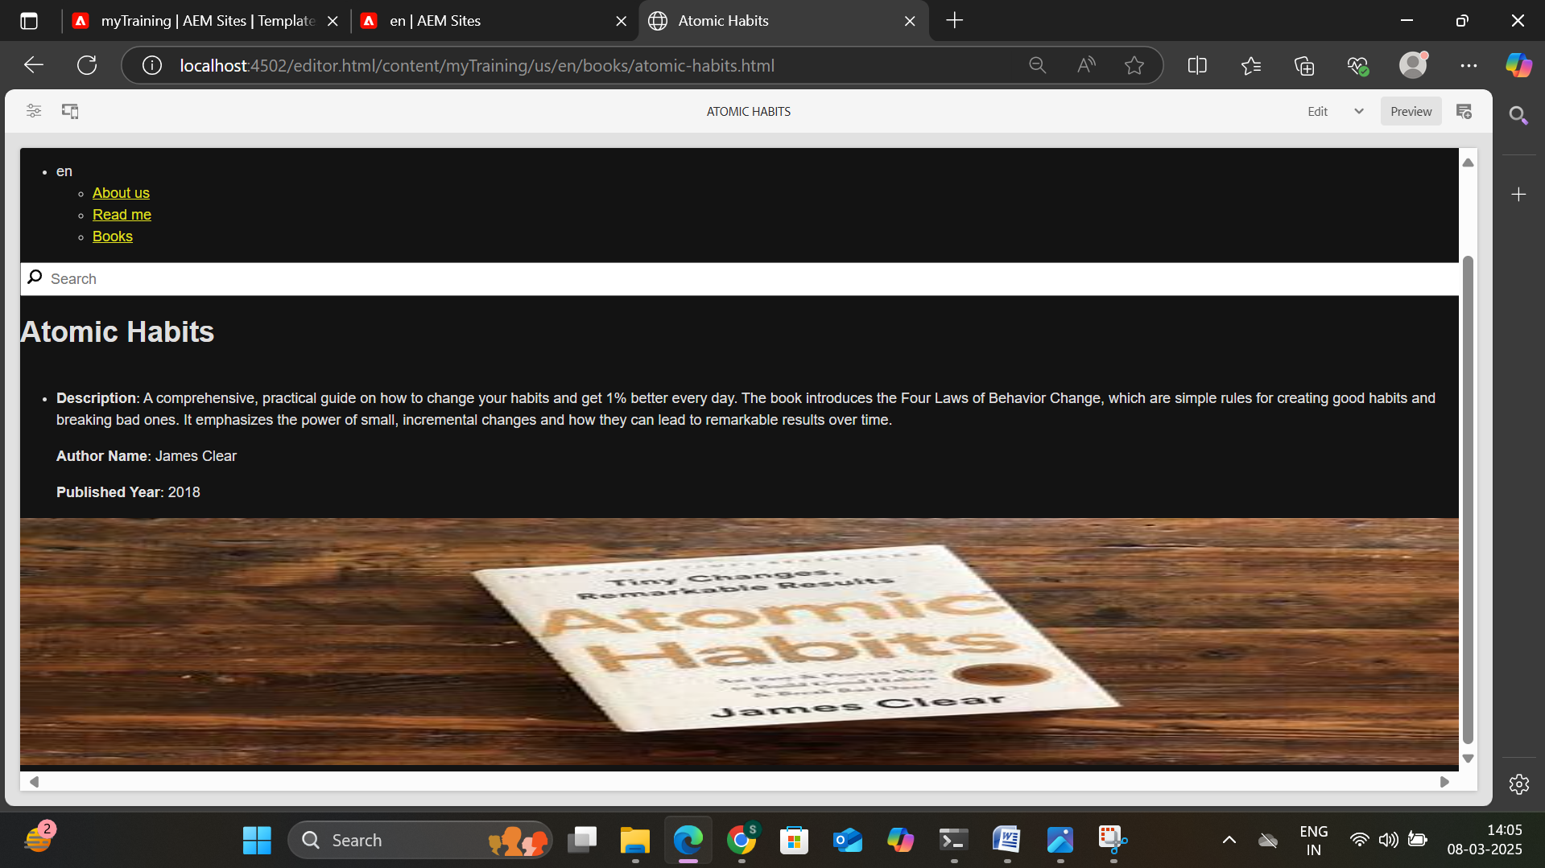

IKIGAI

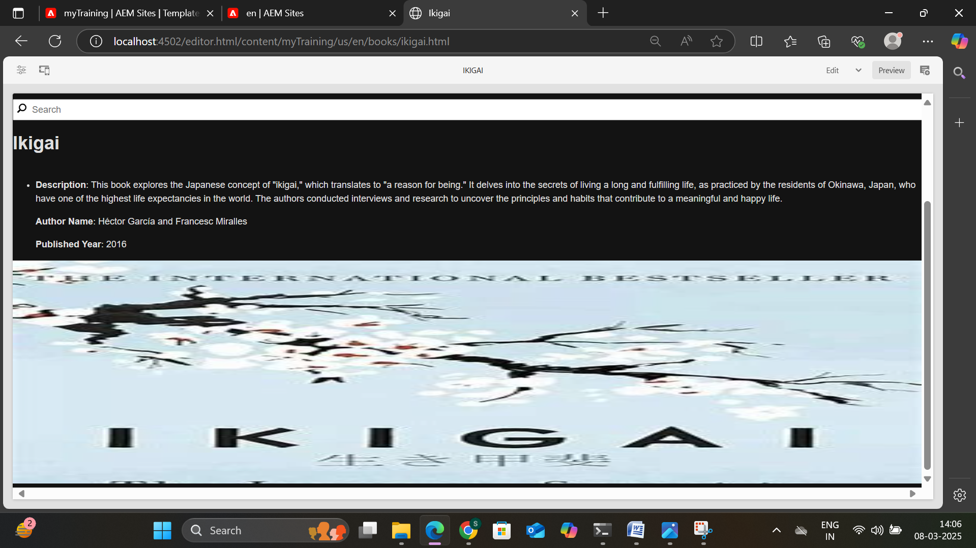

SOLO LEVELING

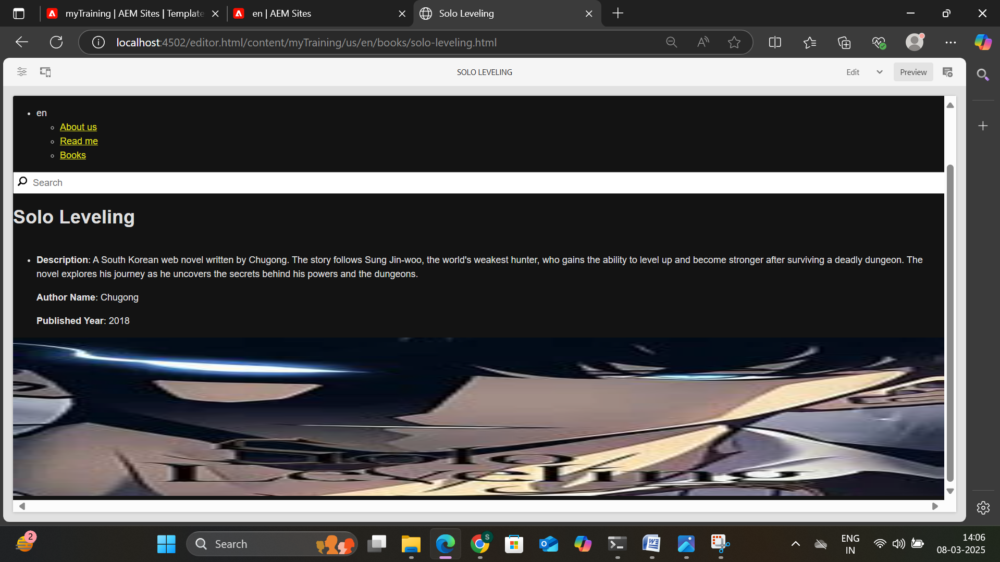

The **AEM Book Page Concept** is a structured approach for creating book-related content within Adobe Experience Manager (AEM). It typically involves the following elements:

1. **Book Detail Template**: A custom AEM template that serves as the structure for displaying detailed information about each book. It includes placeholders for content such as the book title, description, author, publication date, and other metadata.
2. **Book-Detail Component**: A reusable AEM component that encapsulates the logic for displaying the individual details of a book. It pulls information from the book's metadata and ensures consistency across the book pages.
3. **Book Pages**: These are the individual pages representing each book, typically containing specific information, images, and links related to that book. In your project, there would be 10 such pages.
4. **Navigation (Header)**: A navigation header that allows users to easily browse through the book pages or other sections of the website. It typically includes links to other books, categories, or website sections.
5. **Footer**: The footer contains general information about the website, like copyright, contact information, or additional navigation links.
6. **Multifield Component**: A multifield component that allows content authors to input multiple values for certain fields, such as adding multiple authors, genres, or tags for each book.

This concept is designed to create a dynamic, manageable, and user-friendly system for presenting book-related content on an AEM-based website.